Level 7 -> Level 8

The goal of this level is to find the pass to log into <http://natas8.natas.labs.overthewire.org>.

Username: natas8

After logging into level 7 there is no hint to get the next password.

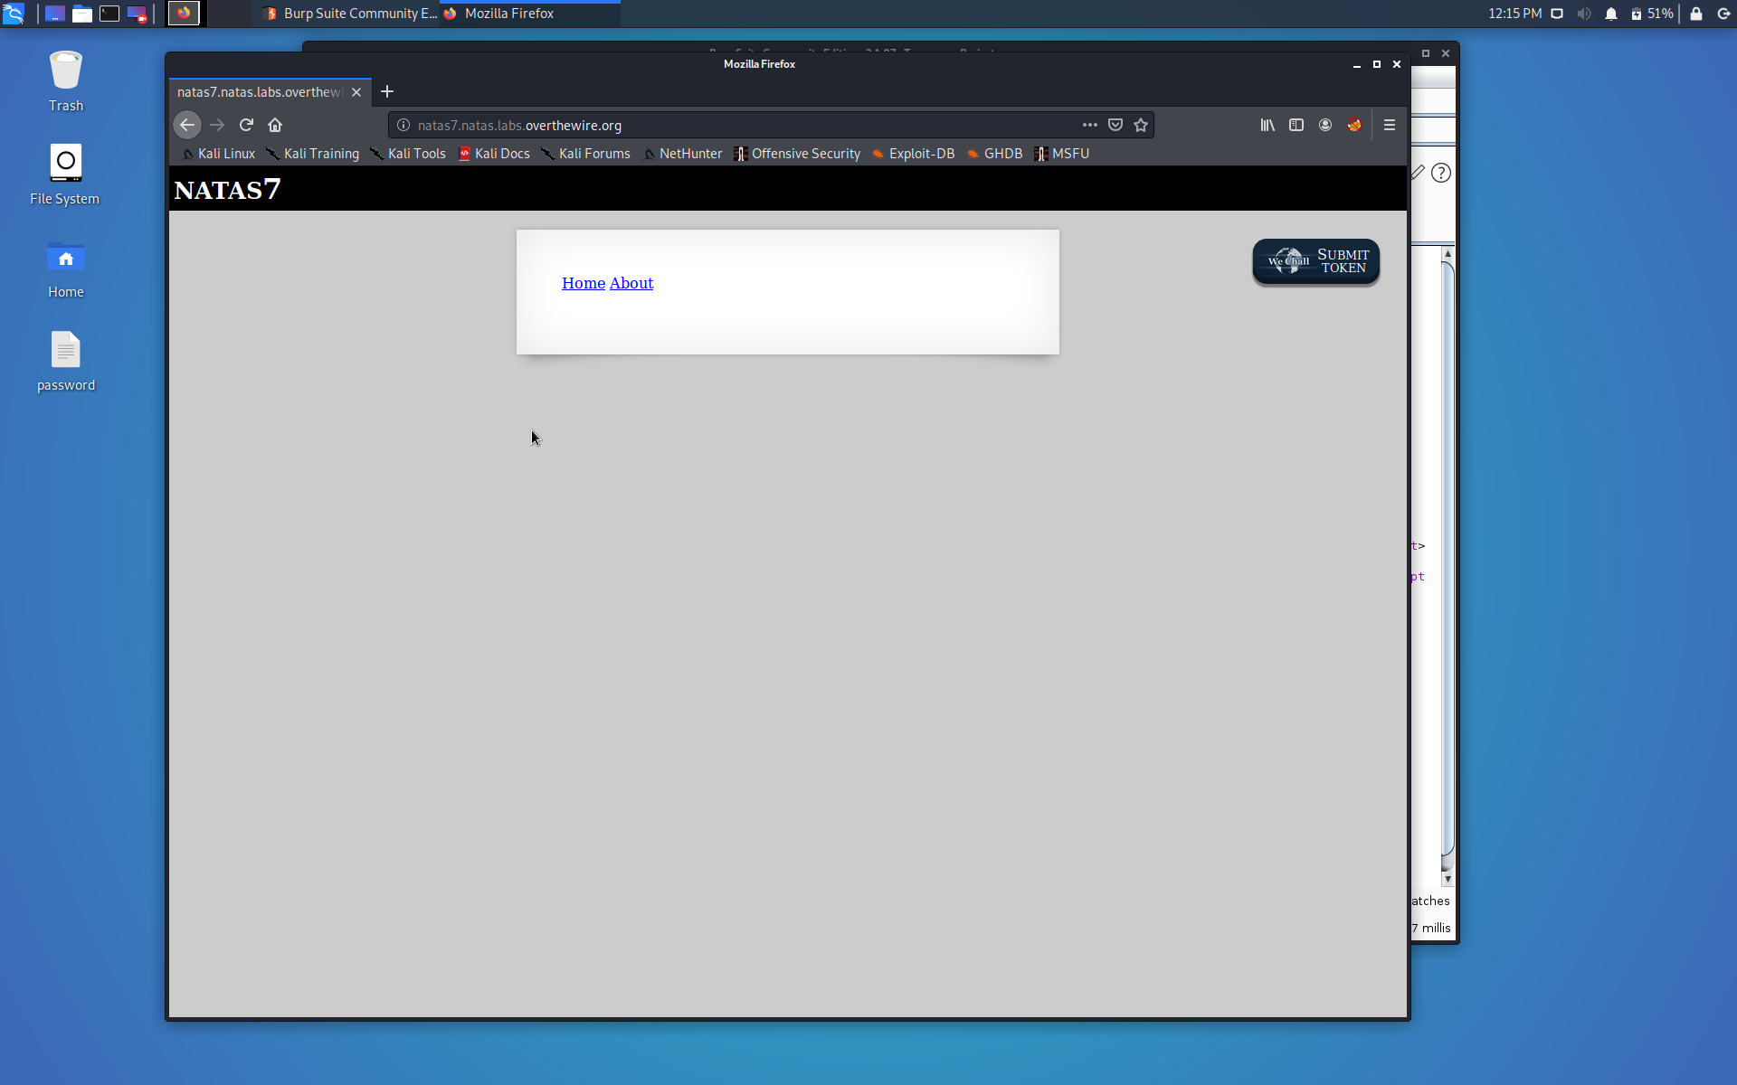

We can try to find something inside the source code. There is the hint for the password commented in the source code.

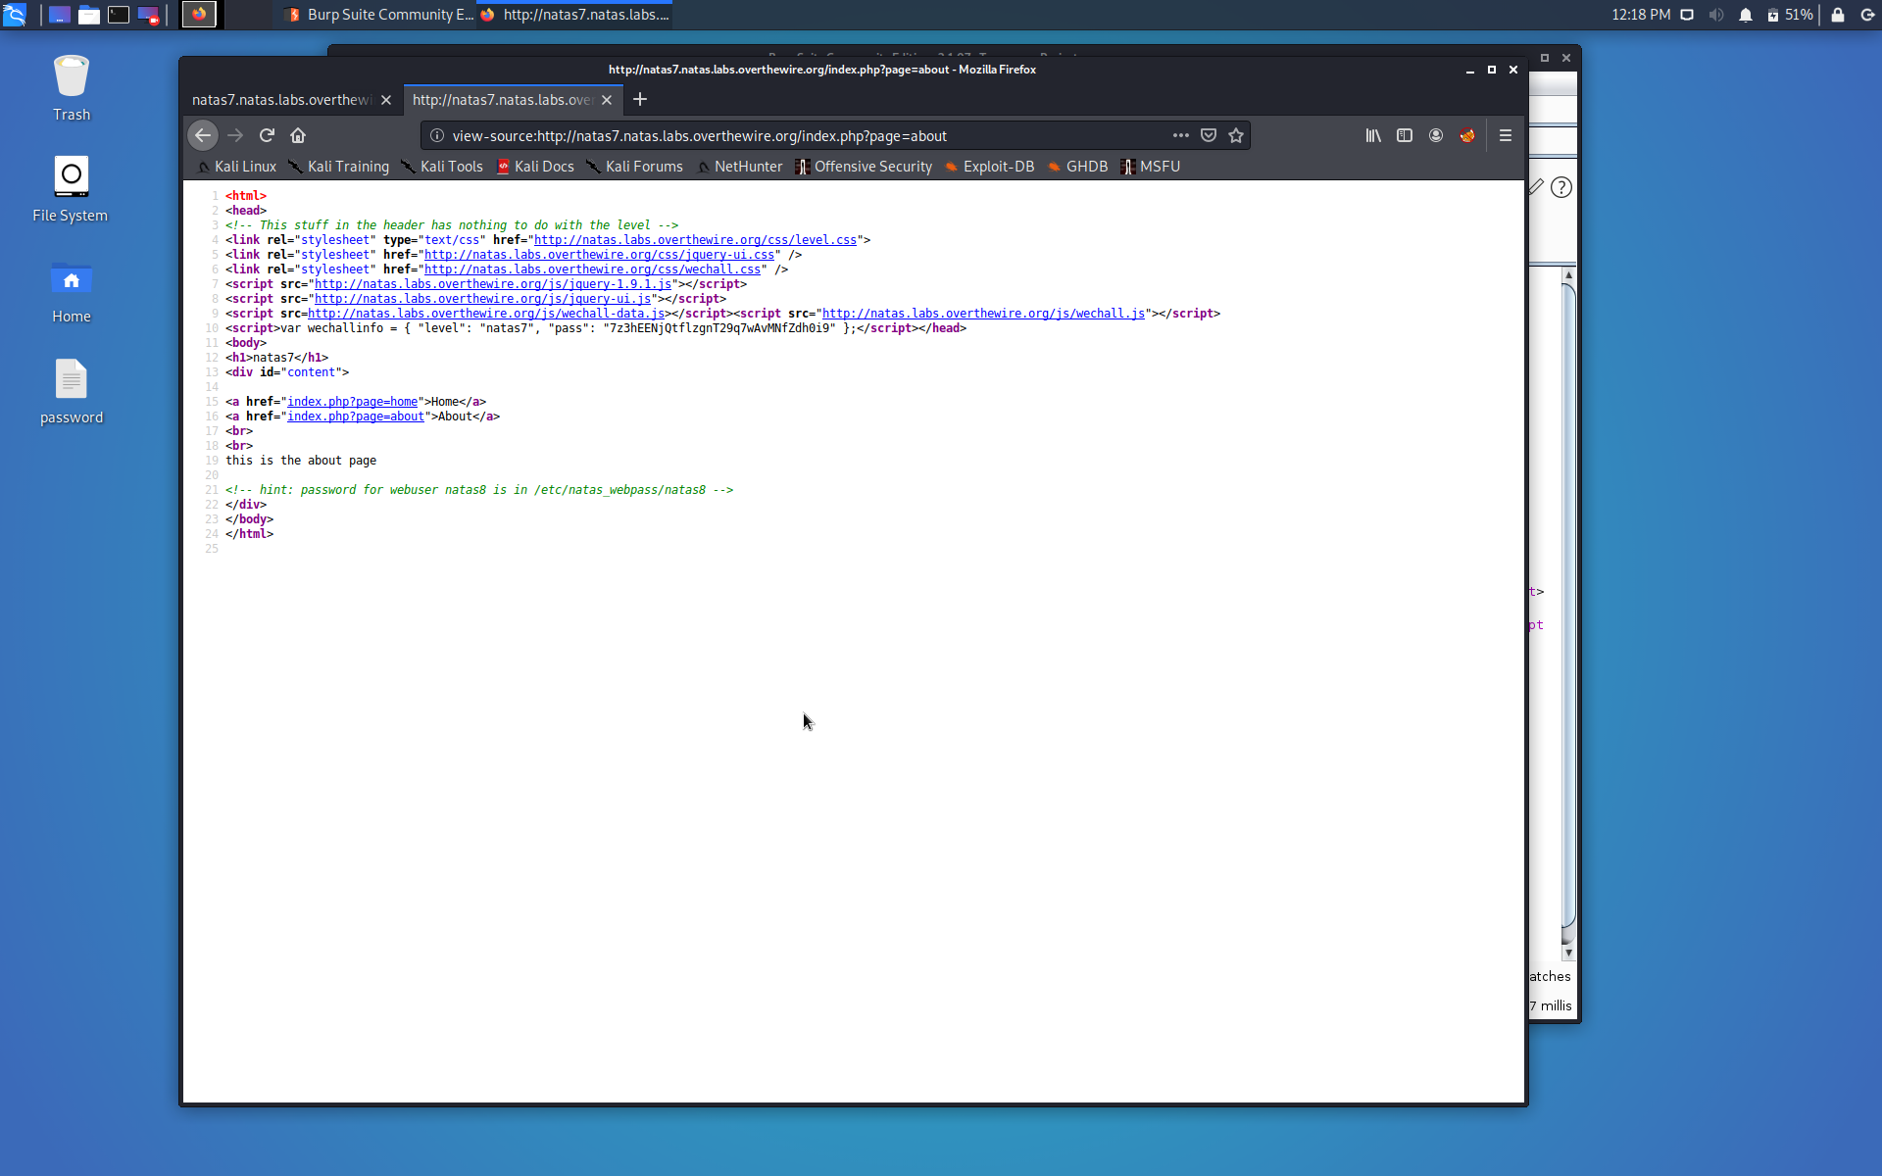

Password is at **/etc/natas_webpass/natas8**. So, edit the URL:

[**http://natas7.natas.labs.overthewire.org/index.php?page=/etc/natas_webpass/natas8**](http://natas7.natas.labs.overthewire.org/index.php?page=/etc/natas_webpass/natas8)**.**

**Here, is the password:**

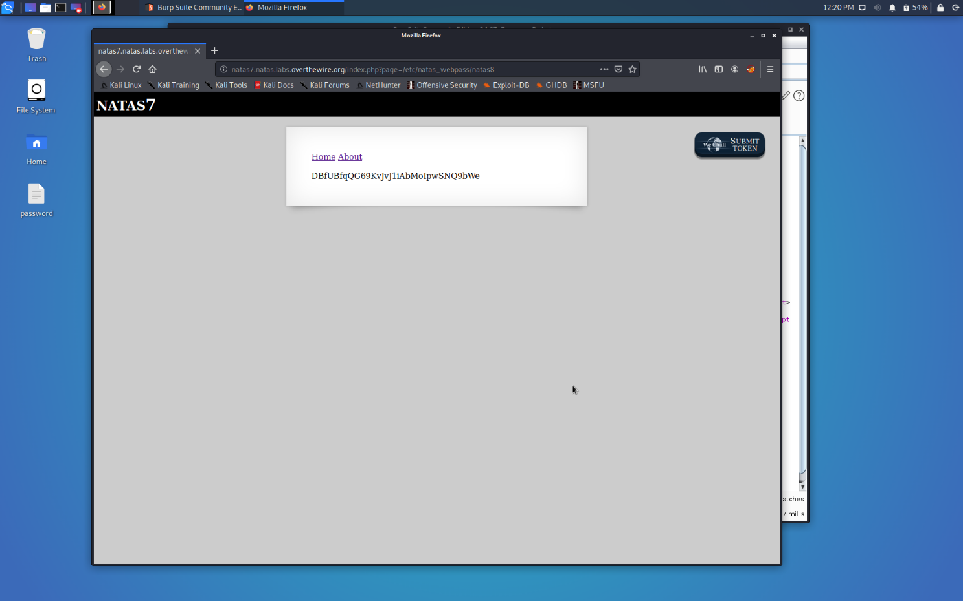

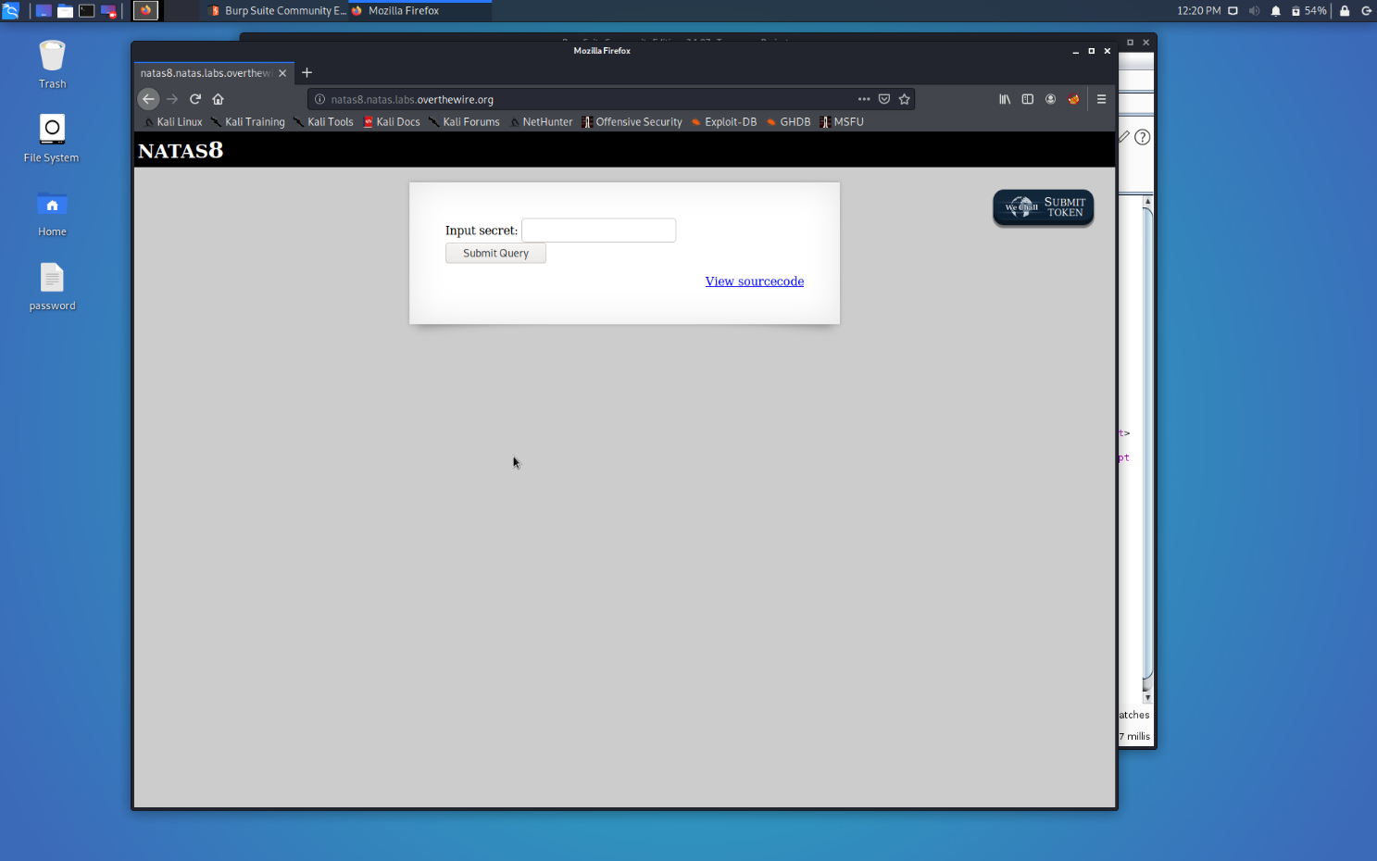

Successfully passed level 8.… 